Name : Arka Haldi

Date : 10/8/2020

UID : 2018130014

**Data Communication and Computer**

**Networks Lab**

**EXPERIMENT 1**

**Study of different types of physical layer wired/wireless connections**

* **The Open Systems Interconnection (OSI) model :**

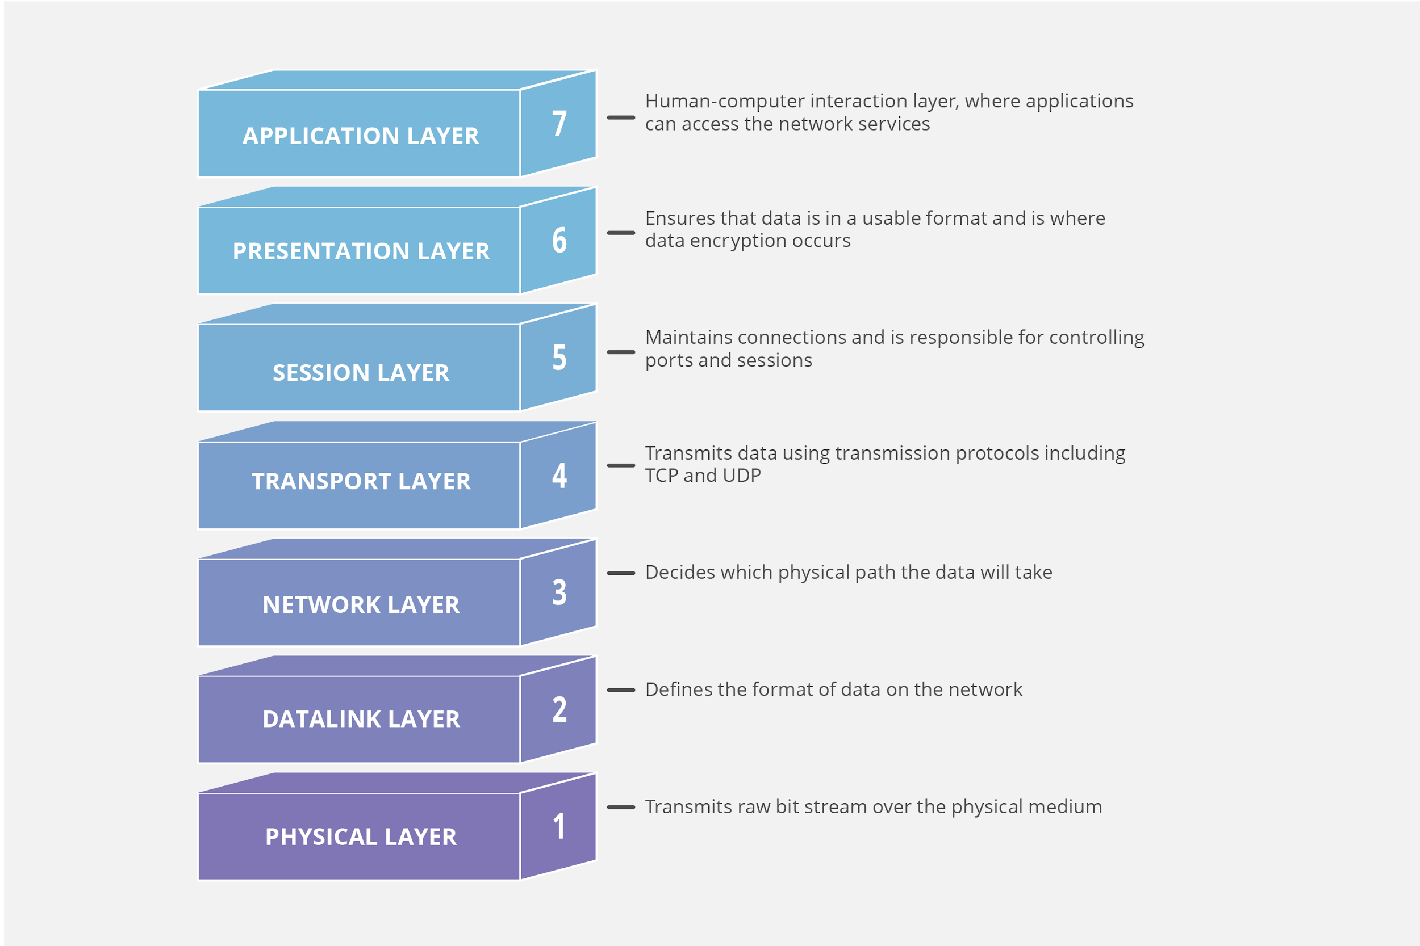

* The **Open Systems Interconnection model (OSI model)** is a conceptual model whose goal is the interoperability of diverse communication systems with standard communication protocols. The model partitions a communication system into **abstraction layers**. In this model, each layer serves the layer above it.
* The model is a product of the Open Systems Interconnection project at the **International Organization for Standardization (ISO)**.
* We limit our discussion to the lowest layer at the foundation of the Computer Networks, and see how they are connected, and it’s different forms, over transmission medium.
* **Physical Layer - OSI Reference Model :**

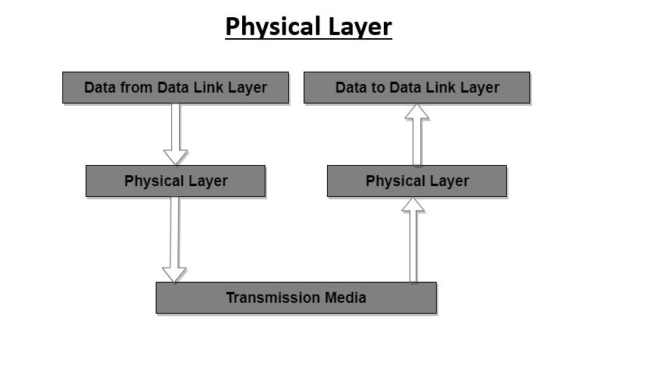

* Physical layer is the **lowest layer** of the OSI reference model and the only layer which provides hardware interaction. It is responsible for sending bits from one computer to another. The physical layer provides an electrical, mechanical, and procedural interface to the transmission medium. This layer is not concerned with the meaning of the bits and deals with the **setup of physical connection** to the network and with **transmission and reception of signals**.
* In our further discussions we divide the Physical Layer into two categories as per medium of transmission, discuss their range and specifications and show their scalability and applicability in different architectures such as LAN, WAN, MAN, etc.

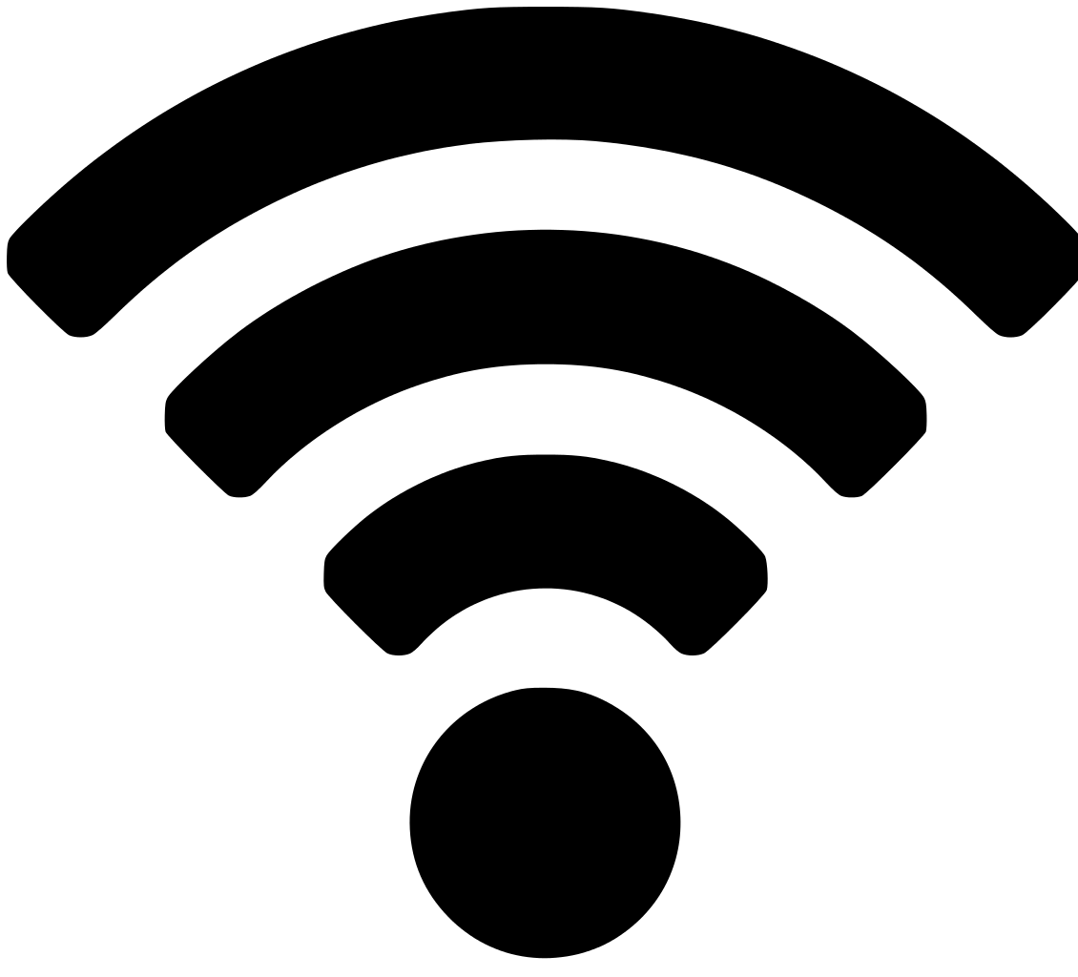

* **Wireless Transmission Media**
* Wireless networking is a method by which homes, telecommunications networks and business installations avoid the costly process of introducing cables into a building, or as a connection between various equipment locations. This implementation takes place at the physical level (layer) of the OSI model network structure.
* Advances in **MOSFET** technology, and the wide adoption of RF CMOS (radio frequency CMOS), power MOSFET and LDMOS (lateral diffused MOS) devices led to the increase of digital wireless networks by the 1990s, and further advances led to increased bandwidth in the 2000s. Most of the essential elements of wireless networks are built from MOSFETs, including the mobile transceivers, base station modules, routers, RF power amplifiers, telecommunication circuits, RF circuits, and radio transceivers, in networks such as 2G, 3G, and 4G.
* **Range and specifications of some wireless media :**

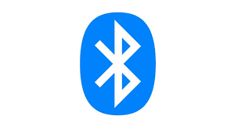

1. **Bluetooth**

* used for exchanging data between fixed and mobile devices over short distances using short-wavelength **UHF radio waves** in the [industrial, scientific and medical radio bands](https://en.wikipedia.org/wiki/ISM_band), from **2.402 GHz** to **2.480 GHz**, and building [**personal area networks**](https://en.wikipedia.org/wiki/Personal_area_network) (PANs)
* Bluetooth is a [packet-based protocol](https://en.wikipedia.org/wiki/Packet_switching) with a [**master/slave** architecture](https://en.wikipedia.org/wiki/Master/slave_(technology)). One master may communicate with **up to seven** slaves in a [piconet](https://en.wikipedia.org/wiki/Piconet). All devices within a given piconet use the clock provided by the master as the base for packet exchange. The master clock ticks with a period of 312.5 [μs](https://en.wikipedia.org/wiki/%CE%9Cs), two clock ticks then make up a slot of 625 µs, and two slots make up a slot pair of 1250 µs. In the simple case of single-slot packets, the master transmits in even slots and receives in odd slots. The slave, conversely, receives in even slots and transmits in odd slots. Packets may be 1, 3 or 5 slots long, but in all cases the master's transmission begins in even slots and the slave's in odd slots
* Bluetooth is a standard wire-replacement communications protocol primarily designed for low power consumption, with a **short range based** on low-cost [**transceiver**](https://en.wikipedia.org/wiki/Transceiver)[**microchips**](https://en.wikipedia.org/wiki/Integrated_circuit) in each device. Because the devices use a radio (broadcast) communications system, they do not have to be in visual line of sight of each other; however, a [quasi optical](https://en.wikipedia.org/wiki/Quasi-optical) wireless path must be viable. Range is power-class-dependent, but effective ranges vary in practice.
* Most Bluetooth applications are battery-powered Class 2 devices, with little difference in range whether the other end of the link is a Class 1 or Class 2 device as the lower-powered device tends to set the range limit. The **Bluetooth Core Specification** mandates a range of not less than **10 metres**, but there is no upper limit on actual range. Manufacturers' implementations can be tuned to provide the range needed for each case.

|  |  |  |  |
| --- | --- | --- | --- |
| **Class** | **Max. permitted power** | | **Typ. range**  **(m)** |
| **(mW)** | **(**[**dBm**](https://en.wikipedia.org/wiki/DBm)**)** |
| **1** | 100 | 20 | ~100 |
| **1.5**  (BT 5 Vol 6 Part A Sect 3) | 10 | 10 | ~20 |
| **2** | 2.5 | 4 | ~10 |
| **3** | 1 | 0 | ~1 |
| **4** | 0.5 | −3 | ~0.5 |



1. **Infrared technology**

* IR data transmission is employed in **short-range communication** among computer peripherals and [personal digital assistants](https://en.wikipedia.org/wiki/Personal_digital_assistant). These devices usually conform to standards published by [**IrDA**](https://en.wikipedia.org/wiki/Infrared_Data_Association)**, the Infrared Data Association**.
* Remote controls and IrDA devices use infrared [light-emitting diodes](https://en.wikipedia.org/wiki/Light-emitting_diode) (**LEDs**) to emit infrared radiation that is focused by a plastic [lens](https://en.wikipedia.org/wiki/Lens_(optics)) into a narrow beam. The beam is [modulated](https://en.wikipedia.org/wiki/Modulation), i.e. switched on and off, to prevent interference from other sources of infrared (like sunlight or artificial lighting). The receiver uses a [silicon](https://en.wikipedia.org/wiki/Silicon) [photodiode](https://en.wikipedia.org/wiki/Photodiode) to convert the infrared radiation to an [electric current](https://en.wikipedia.org/wiki/Electric_current). It responds only to the rapidly pulsing signal created by the transmitter, and filters out slowly changing infrared radiation from ambient light.
* Infrared communications are useful for **indoor use** in areas of **high population density**. IR does not penetrate walls and so does not interfere with other devices in adjoining rooms. Infrared is the most common way for [remote controls](https://en.wikipedia.org/wiki/Remote_control) to command appliances. Infrared remote control protocols like [**RC-5**](https://en.wikipedia.org/wiki/RC-5),[**SIRC**](https://en.wikipedia.org/w/index.php?title=Sony_Infrared_Remote_Control&action=edit&redlink=1), are used to communicate with infrared.



1. **ZigBee**

* Zigbee is an [IEEE 802.15.4](https://en.wikipedia.org/wiki/IEEE_802.15.4)-based [specification](https://en.wikipedia.org/wiki/Specification_(technical_standard)) for a suite of high-level communication protocols used to create [personal area networks](https://en.wikipedia.org/wiki/Personal_area_network) with small, low-power [digital radios](https://en.wikipedia.org/wiki/Digital_radio), such as for [**home automation**](https://en.wikipedia.org/wiki/Home_automation), **medical device data collection**, and other **low-power low-bandwidth** needs, designed for small scale projects which need wireless connection. Hence, Zigbee is a low-power, low data rate, and close proximity (i.e., personal area) [wireless ad hoc network](https://en.wikipedia.org/wiki/Wireless_ad_hoc_network).
* Its low power consumption limits transmission distances to 10–100 meters [line-of-sight](https://en.wikipedia.org/wiki/Line-of-sight_propagation), depending on power output and environmental characteristics. Zigbee devices can transmit data over long distances by passing data through a [**mesh network**](https://en.wikipedia.org/wiki/Mesh_networking) of intermediate devices to reach more distant ones. Zigbee is typically used in **low data rate applications** that require long battery life and secure networking (Zigbee networks are secured by 128 bit [symmetric encryption](https://en.wikipedia.org/wiki/Symmetric-key_algorithm) keys.) Zigbee has a defined rate of **250 kbit/s**, best suited for intermittent data transmissions from a sensor or input device.
* The **ZigBee Smart Energy 2.0** specifications define an [**Internet Protocol**](https://en.wikipedia.org/wiki/Internet_Protocol)**-based** [**communication protocol**](https://en.wikipedia.org/wiki/Communication_protocol) to monitor, control, inform, and automate the delivery and use of energy and water. It is an enhancement of the ZigBee Smart Energy version 1 specifications. It adds services for [plug-in electric vehicle](https://en.wikipedia.org/wiki/Plug-in_electric_vehicle) charging, installation, configuration and firmware download, prepay services, user information and messaging, load control, [demand response](https://en.wikipedia.org/wiki/Demand_response) and common information and application profile interfaces for wired and wireless networks.

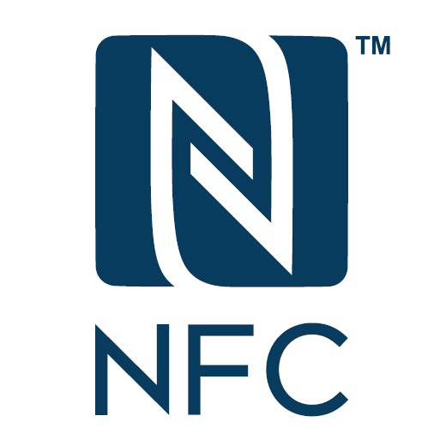

1. **Near Field Communication (NFC)**

* Near-Field-Communication (NFC) is a set of [communication protocols](https://en.wikipedia.org/wiki/Communications_protocol) for [communication](https://en.wikipedia.org/wiki/Data_communication) between two electronic devices over a distance of **4 cm or less**. NFC offers a low-speed connection with simple setup that can be used to [bootstrap](https://en.wikipedia.org/wiki/Bootstrapping) more-capable wireless connections.
* NFC devices can act as **electronic** [**identity documents**](https://en.wikipedia.org/wiki/Identity_document) and [**keycards**](https://en.wikipedia.org/wiki/Keycard_lock). They are used in [contactless payment](https://en.wikipedia.org/wiki/Contactless_payment) systems and allow [mobile payment](https://en.wikipedia.org/wiki/Mobile_payment) replacing or supplementing systems such as **credit cards** and [**electronic ticket**](https://en.wikipedia.org/wiki/Electronic_ticket) **smart cards**. NFC tags are passive data stores which can be read, and under some circumstances written to, by an NFC device. They typically contain data (as of 2015 between 96 and 8,192 bytes) and are read-only in normal use, but may be rewritable.
* Like other "[proximity card](https://en.wikipedia.org/wiki/Proximity_card)" technologies, NFC is based on [**inductive coupling**](https://en.wikipedia.org/wiki/Inductive_coupling) between two so-called [antennas](https://en.wikipedia.org/wiki/Electromagnetic_coil) present on NFC-enabled devices—for example a smartphone and a printer—communicating in one or both directions, using a frequency of **13.56 MHz** in the globally available unlicensed [radio frequency](https://en.wikipedia.org/wiki/Radio_frequency) [ISM band](https://en.wikipedia.org/wiki/ISM_band) using the [ISO/IEC 18000-3](https://en.wikipedia.org/wiki/ISO/IEC_18000-3) air interface standard at data rates ranging from **106 to 424 kbit/s**.

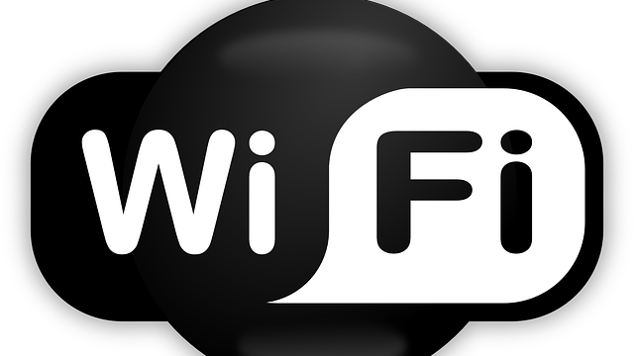

1. **Wireless Fidelity**

* Wi-Fi is a family of [wireless network](https://en.wikipedia.org/wiki/Wireless_network) [protocols](https://en.wikipedia.org/wiki/Communication_protocol), based on the [IEEE 802.11](https://en.wikipedia.org/wiki/IEEE_802.11) family of standards, which are commonly used for [**local area networking**](https://en.wikipedia.org/wiki/Wireless_LAN) of devices and [Internet](https://en.wikipedia.org/wiki/Internet) access. Wi-Fi uses multiple parts of the [IEEE 802](https://en.wikipedia.org/wiki/IEEE_802) [protocol](https://en.wikipedia.org/wiki/Communication_protocol) family and is designed to interwork seamlessly with its wired sibling [**Ethernet**](https://en.wikipedia.org/wiki/Ethernet). Compatible devices can network through [**wireless access points**](https://en.wikipedia.org/wiki/Wireless_access_point) to each other as well as to **wired devices** and the **Internet**.
* Wi-Fi stations communicate by sending each other [data packets](https://en.wikipedia.org/wiki/Data_packet): blocks of data individually sent and delivered over radio. As with all radio, this is done by the [modulating and demodulation](https://en.wikipedia.org/wiki/Modem) of [carrier waves](https://en.wikipedia.org/wiki/Carrier_wave). Different versions of Wi-Fi use different techniques, 802.11b uses [DSSS](https://en.wikipedia.org/wiki/DSSS) on a **single carrier**, whereas 802.11a, Wi-Fi 4, 5 and 6 use **multiple carriers** on slightly different frequencies within the channel ([OFDM](https://en.wikipedia.org/wiki/OFDM)).
* The [802.11](https://en.wikipedia.org/wiki/IEEE_802.11) standard provides several distinct [radio frequency](https://en.wikipedia.org/wiki/Radio_frequency) ranges for use in Wi-Fi communications: **900 MHz, 2.4 GHz, 5 GHz, 5.9 GHz, and 60 GHz** [bands](https://en.wikipedia.org/wiki/Band_(radio)). Each range is divided into a multitude of [channels](https://en.wikipedia.org/wiki/Channel_(communications)). Countries apply their own regulations to the allowable channels, allowed users and maximum power levels within these frequency ranges. The ISM band ranges are also often used. Channels can be shared between networks but only one transmitter can locally transmit on a channel at any moment in time.
* An access point (or [hotspot](https://en.wikipedia.org/wiki/Hotspot_(Wi-Fi))) often has a range of about **20 metres** indoors while some modern access points claim up to a **150-metre** range outdoors. Hotspot coverage can be as small as a single room with walls that block radio waves, or as large as **many square kilometres** using many **overlapping access points** with [**roaming**](https://en.wikipedia.org/wiki/Roaming) permitted between them. Over time the speed and spectral efficiency of Wi-Fi have increased. As of 2019, at close range, some versions of Wi-Fi, running on suitable hardware, can achieve speeds of over **1 Gbit/s**.
* Coverage in the larger area may require a group of access points with overlapping coverage. For example, public **outdoor Wi-Fi** technology has been used successfully in [wireless **mesh networks**](https://en.wikipedia.org/wiki/Wireless_mesh_network)in London. An international example is [**Fon**](https://en.wikipedia.org/wiki/Fon_(company)). Many traditional university campuses in the developed world provide at least partial Wi-Fi coverage. [Carnegie Mellon University](https://en.wikipedia.org/wiki/Carnegie_Mellon_University) built the first **campus-wide** wireless Internet network, called [**Wireless Andrew**](https://en.wikipedia.org/wiki/Wireless_Andrew), at its [Pittsburgh](https://en.wikipedia.org/wiki/Pittsburgh) campus in 1993 before Wi-Fi branding originated.
* In the early 2000s, many cities around the world announced plans to construct **citywide** Wi-Fi networks. There are many successful examples; in 2004, [**Mysore**](https://en.wikipedia.org/wiki/Mysore) (Mysuru) became India's first Wi-Fi-enabled city. A company called **WiFiyNet** has set up hotspots in Mysore, covering the complete city and a few nearby villages.

1. **Cellular Network**

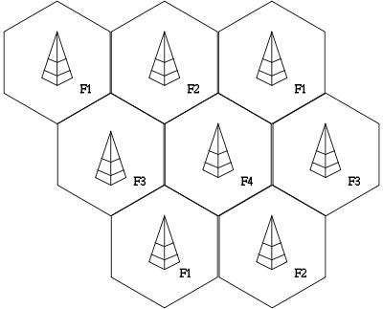

* A cellular network or mobile network is a **radio network** distributed over land areas called cells, each served by at least one fixed-location [transceiver](https://en.wikipedia.org/wiki/Transceiver), known as a [cell site](https://en.wikipedia.org/wiki/Cell_site) or [base station](https://en.wikipedia.org/wiki/Base_station). In a cellular network, each cell characteristically uses a different set of radio frequencies from all their immediate neighbouring cells to avoid any interference.
* When joined together these cells provide radio coverage over a wide geographic area. This enables a large number of portable transceivers (e.g., mobile phones, [pagers](https://en.wikipedia.org/wiki/Pager), etc.) to communicate with each other and with fixed transceivers and telephones anywhere in the network, via **base stations**, even if some of the transceivers are moving through more than one cell during transmission.
* Although originally intended for cell phones, with the development of [smartphones](https://en.wikipedia.org/wiki/Smartphone), [cellular telephone networks](https://en.wikipedia.org/wiki/Cellular_network) routinely carry data in addition to telephone conversations:
  + [**Global System for Mobile Communications**](https://en.wikipedia.org/wiki/Global_System_for_Mobile_Communications) (GSM): The GSM network is divided into three major systems: the switching system, the base station system, and the operation and support system. The cell phone connects to the base system station which then connects to the operation and support station; it then connects to the switching station where the call is transferred to where it needs to go. GSM is the most common standard and is used for a majority of cell phones.
  + [**Personal Communications Service**](https://en.wikipedia.org/wiki/Personal_Communications_Service) (PCS): PCS is a radio band that can be used by mobile phones in North America and South Asia. Sprint happened to be the first service to set up a PCS.
  + [**D-AMPS**](https://en.wikipedia.org/wiki/D-AMPS): Digital Advanced Mobile Phone Service, an upgraded version of AMPS, is being phased out due to advancement in technology. The newer GSM networks are replacing the older system.
* **Use of Wireless media in different network architectures :**
* The different mediums discussed above are used in some network type or the other. Here are some interesting points about Wireless Network types :

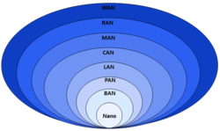

1. **Wireless PAN (Personal Area Network)**

* WPANs connect devices within a relatively small area, that is generally within a person's reach. For example, both [**Bluetooth**](https://en.wikipedia.org/wiki/Bluetooth)radio and invisible [**infrared**](https://en.wikipedia.org/wiki/Infrared) light provides a WPAN for interconnecting a headset to a laptop. [**ZigBee**](https://en.wikipedia.org/wiki/ZigBee) also supports WPAN applications. Wi-Fi PANs are becoming commonplace (2010) as equipment designers start to integrate Wi-Fi into a variety of consumer electronic devices. [**Intel**](https://en.wikipedia.org/wiki/Intel) **"My WiFi"** and [**Windows 7**](https://en.wikipedia.org/wiki/Windows_7) **"**[**virtual**](https://en.wikipedia.org/wiki/Virtuality) **Wi-Fi"** capabilities have made Wi-Fi PANs simpler and easier to set up and configure.
* New wireless technology from Intel called My WiFi, available to Centrino 2-based laptops, makes the computer's wireless adapter work concurrently as an **adapter** and a **wireless router**. The technology enables users to simultaneously connect their laptops to multiple other **peripheral devices**, such as printers, photo frames, and cameras without a need for an access point or a wireless router.
* Virtual Wifi allows you to **share any Internet connection type**, to keep all your devices online wherever you go, either via Wi-Fi, tethered 3G / 4G connection or wired Ethernet. You can even [share a VPN connection over Wi-Fi](https://www.connectify.me/share-vpn-over-wifi-hotspot/) to protect all your connected devices.

1. **Wireless LAN (Local Area Network)**

* A [wireless local area network](https://en.wikipedia.org/wiki/Wireless_local_area_network) (WLAN) links two or more devices over a short distance using a wireless distribution method, usually providing a connection through an **access point** for internet access. The use of [spread-spectrum](https://en.wikipedia.org/wiki/Spread-spectrum) or [OFDM](https://en.wikipedia.org/wiki/OFDM) technologies may allow users to move around within a local coverage area, and still remain connected to the network.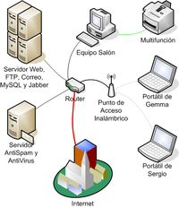
* Products using the [IEEE 802.11](https://en.wikipedia.org/wiki/IEEE_802.11) WLAN standards are marketed under the [**Wi-Fi**](https://en.wikipedia.org/wiki/Wi-Fi) brand name . To connect to [Wi-Fi](https://en.wikipedia.org/wiki/Wi-Fi), sometimes devices like a [router](https://en.wikipedia.org/wiki/Router_(computing)) or connecting [HotSpot](https://en.wikipedia.org/wiki/Hotspot_(Wi-Fi)) using mobile smartphones are used.
* **Fixed wireless data (FWD)** links are often a cost-effective alternative to leasing fiber or installing cables between the buildings. [Fixed wireless](https://en.wikipedia.org/wiki/Fixed_wireless) technology implements [point-to-point](https://en.wikipedia.org/wiki/Point-to-point_(telecommunications)) links between computers or networks at two distant locations, often using dedicated [**microwave**](https://en.wikipedia.org/wiki/Microwave) or **modulated** [**laser light**](https://en.wikipedia.org/wiki/Laser_light) **beams** over [line of sight](https://en.wikipedia.org/wiki/Line-of-sight_propagation) paths. It is often used in **cities** to connect networks in two or more buildings without installing a wired link.

1. **Wireless Ad Hoc Network**

* A wireless ad hoc network, also known as a [**wireless mesh network**](https://en.wikipedia.org/wiki/Wireless_mesh_network) **or** [**mobile ad hoc network**](https://en.wikipedia.org/wiki/Mobile_ad_hoc_network) **(MANET)**, is a wireless network made up of **radio nodes organized in a mesh topology**. Each node forwards messages on behalf of the other nodes and each node performs routing. Ad hoc networks can "**self-heal**", automatically rerouting around a node that has lost power. Various network layer protocols are needed to realize ad hoc mobile networks, such as Distance Sequenced Distance Vector routing, [Associativity-Based Routing](https://en.wikipedia.org/wiki/Associativity-Based_Routing), Ad hoc on-demand [Distance Vector routing](https://en.wikipedia.org/wiki/Distance-vector_routing_protocol), and [Dynamic source routing](https://en.wikipedia.org/wiki/Dynamic_Source_Routing).

1. **Wireless MAN (Metropolitan Area Network)**

* Wireless [metropolitan area networks](https://en.wikipedia.org/wiki/Metropolitan_area_network) are a type of wireless network that connects several wireless LANs. [**WiMAX**](https://en.wikipedia.org/wiki/WiMAX) (Worldwide Interoperability for Microwave Access) is a type of Wireless MAN and is described by the [IEEE 802.16](https://en.wikipedia.org/wiki/IEEE_802.16) standard. WiMAX can provide at-home or mobile [Internet access](https://en.wikipedia.org/wiki/Internet_access) across whole cities or countries. In many cases, this has resulted in competition in markets which typically only had access through an existing incumbent DSL (or similar) operator.
* **Mobile WiMAX** was a replacement candidate for [cellular phone](https://en.wikipedia.org/wiki/Cellular_phone) technologies such as [**GSM**](https://en.wikipedia.org/wiki/GSM) and [**CDMA**](https://en.wikipedia.org/wiki/Code_division_multiple_access), or can be used as an overlay to increase capacity. Fixed WiMAX is also considered as a wireless [backhaul](https://en.wikipedia.org/wiki/Backhaul_(telecommunications)) technology for [2G](https://en.wikipedia.org/wiki/2G), [3G](https://en.wikipedia.org/wiki/3G), and [4G](https://en.wikipedia.org/wiki/4G) networks in both developed and developing nations.

1. **Wireless WAN (Wide Area Network)**

* [Wireless wide area networks](https://en.wikipedia.org/wiki/Wireless_WAN) are wireless networks that typically cover large areas, such as between neighbouring towns and cities, or city and suburb. These networks can be used to connect branch offices of business or as a public Internet access system. The wireless connections between access points are usually [**point to point**](https://en.wikipedia.org/wiki/Point-to-point_(telecommunications))[**microwave links**](https://en.wikipedia.org/wiki/Microwave_transmission) **using** [**parabolic dishes**](https://en.wikipedia.org/wiki/Parabolic_dish) on the **2.4 GHz and 5.8Ghz band**, rather than [omnidirectional antennas](https://en.wikipedia.org/wiki/Omnidirectional_antenna) used with smaller networks. A typical system contains base station gateways, access points and wireless bridging relays. Other configurations are mesh systems where each access point acts as a relay also. When combined with renewable energy systems such as photovoltaic solar panels or wind systems they can be stand alone systems.

1. **Global Area Network**

* A [global area network](https://en.wikipedia.org/wiki/Global_area_network) (GAN) is a network used for **supporting mobile** across an arbitrary number of **wireless LANs**, **satellite coverage areas**, etc. The key challenge in mobile communications is handing off user communications from one local coverage area to the next. In IEEE Project 802, this involves a succession of terrestrial [wireless LANs](https://en.wikipedia.org/wiki/Wireless_LAN).

1. **Global Satellite Network**

* [Communication satellites](https://en.wikipedia.org/wiki/Communication_satellite) are an important part of global networks. However, there are specific [low Earth orbit](https://en.wikipedia.org/wiki/Low_Earth_orbit) (LEO) global [satellite constellations](https://en.wikipedia.org/wiki/Satellite_constellation), such as [**Iridium**](https://en.wikipedia.org/wiki/Iridium_satellite_constellation), [**Globalstar**](https://en.wikipedia.org/wiki/Globalstar) and [**Orbcomm**](https://en.wikipedia.org/wiki/Orbcomm), which are comprised by dozens of similar satellites which are put in orbit at regularly spaced positions and form a [**mesh network**](https://en.wikipedia.org/wiki/Mesh_network), sometimes sending and receiving information directly among themselves. Using [VSAT](https://en.wikipedia.org/wiki/VSAT) technology, [satellite internet access](https://en.wikipedia.org/wiki/Satellite_internet_access) has become possible.
* **Wired Transmission Media :**
* Wired communication refers to the [transmission of data](https://en.wikipedia.org/wiki/Data_transmission) over a [wire](https://en.wikipedia.org/wiki/Wire)-based [communication technology](https://en.wikipedia.org/wiki/Information_communication_technology). Examples include [telephone networks](https://en.wikipedia.org/wiki/Public_switched_telephone_network), [cable television](https://en.wikipedia.org/wiki/Cable_television) or [internet access](https://en.wikipedia.org/wiki/Cable_internet), and [fiber-optic communication](https://en.wikipedia.org/wiki/Fiber-optic_communication). Most wired networks use Ethernet cables to transfer data between connected PCs.
* Local telephone networks often form the basis for wired communications and are used by both residential and business customers in the area. Many networks today rely on the use of fiber optic communication technology as a means of providing clear signaling for both inbound and outbound transmissions and are replacing copper wire transmission.`
* In general, wired communications are considered to be the most stable of all types of communications services. They are relatively impervious to adverse weather conditions in comparison to wireless communication solutions. These characteristics have allowed wired communications to remain popular even as wireless solutions have continued to advance.
* **Range and specifications of some wired media :**

1. **Twisted Pair Cable**

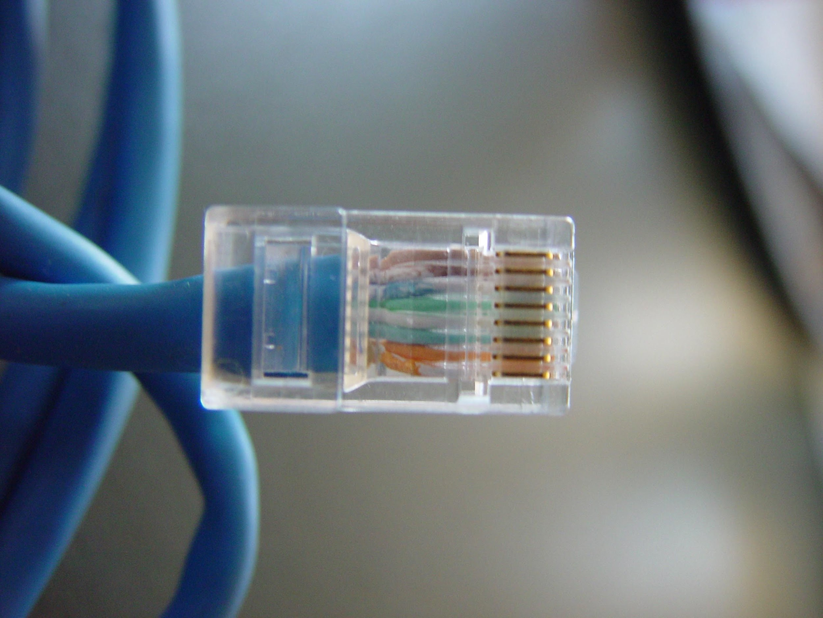

* An Unshielded Twisted Pair (UTP) cable is made of two plastic insulated copper wires twisted together to form a single media. Out of these two wires, only one carries actual signal and another is used for ground reference. The twists between wires are helpful in reducing noise (electro-magnetic interference) and crosstalk. The UTP cables are connected by **RJ45 connectors**. In a Shielded Twisted Pair (STP) cable, the twisted wire pair is additionally covered in a metal foil which increases the noise resistance.
* UTP is also the most common cable used in [computer networking](https://en.wikipedia.org/wiki/Computer_networking). Modern [Ethernet](https://en.wikipedia.org/wiki/Ethernet), the most common data networking standard, can use UTP cables. Twisted-pair cabling is often used in data networks for **short** and **medium**-length connections because of its relatively lower costs compared to [optical fiber](https://en.wikipedia.org/wiki/Optical_fiber) and [coaxial cable](https://en.wikipedia.org/wiki/Coaxial_cable).
* As UTP cable [bandwidth](https://en.wikipedia.org/wiki/Bandwidth_(signal_processing)) has improved to match the [baseband](https://en.wikipedia.org/wiki/Baseband) of [television](https://en.wikipedia.org/wiki/Television) signals, UTP is now used in some [video](https://en.wikipedia.org/wiki/Video) applications, primarily in [security cameras](https://en.wikipedia.org/wiki/Security_camera). As UTP is a balanced transmission line, a [balun](https://en.wikipedia.org/wiki/Balun) is needed to connect to unbalanced equipment, for example any using [BNC connectors](https://en.wikipedia.org/wiki/BNC_connector) and designed for coaxial cable.

1. **Coaxial Cable**

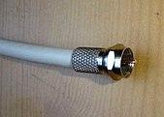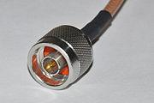

* Coaxial cable, or coax is a type of [electrical cable](https://en.wikipedia.org/wiki/Electrical_cable). It differs from other [shielded cables](https://en.wikipedia.org/wiki/Shielded_cable) because the dimensions of the cable and connectors are controlled to give a precise, constant conductor spacing, which is needed for it to function efficiently as a transmission line. The wrapped structure provides it a good shield against noise and crosstalk.
* Coaxial cable is a type of [transmission line](https://en.wikipedia.org/wiki/Transmission_line), used to carry **high-frequency** [**electrical signals**](https://en.wikipedia.org/wiki/Electrical_signal) with **low losses**. It is used in such applications as **telephone** trunklines, [**broadband** internet](https://en.wikipedia.org/wiki/Internet_access) networking cables, high-speed computer [data busses](https://en.wikipedia.org/wiki/Bus_(computer)), [cable television](https://en.wikipedia.org/wiki/Cable_television) signals, cable Internet and connecting [radio transmitters](https://en.wikipedia.org/wiki/Transmitter) and [receivers](https://en.wikipedia.org/wiki/Radio_receiver) to their [antennas](https://en.wikipedia.org/wiki/Antenna_(radio)).
* Coaxial cables provide high bandwidth rates of up to **450 mbps** and are used in **ethernet systems**, namely the RG-58 (Thick Ethernet) and RG-11 (Thick Ethernet).

1. **Power Lines**

* Power Line communication (PLC) is Layer-1 (Physical Layer) technology which uses **power cables** to transmit data signals. In PLC, modulated data is sent over the cables. The receiver on the other end de-modulates and interprets the data. Because power lines are widely deployed, PLC can make all powered devices controlled and monitored. PLC works in half-duplex. There are two types of PLC: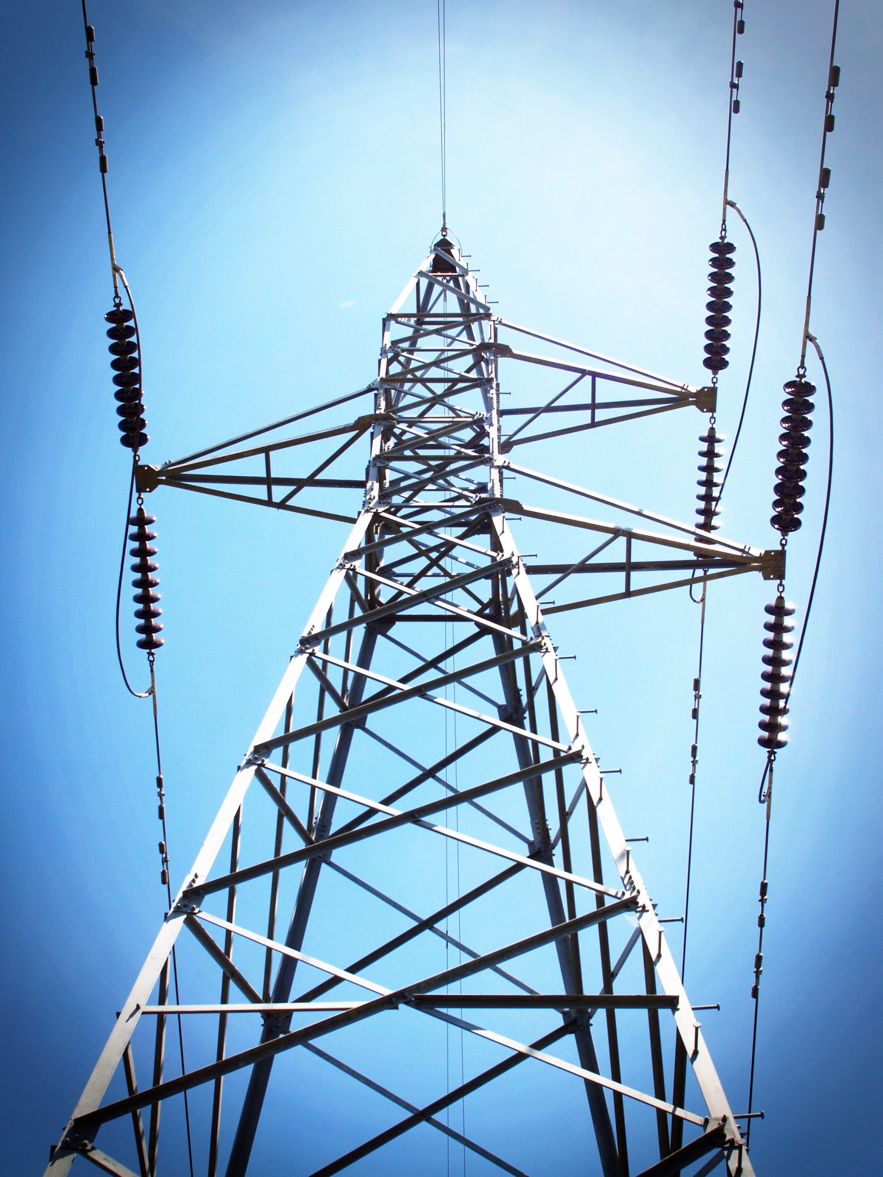
  + Narrow band PLC
  + Broadband PLC

**Narrow band PLC** provides lower data rates up to **100s of kbps**, as they work at lower frequencies (3-5000 kHz).They can be spread over several kilometers.

**Broadband PLC** provides higher data rates up to **100s of Mbps** and works at higher frequencies (1.8 – 250 MHz).They cannot be as much extended as Narrowband PLC.

1. **Fiber Optic Cable**

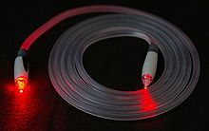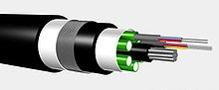

* A fiber-optic cable, also known as an optical-fiber cable, is an assembly similar to an [electrical cable](https://en.wikipedia.org/wiki/Electrical_cable), but containing one or more [optical fibers](https://en.wikipedia.org/wiki/Optical_fiber) that are used to carry light. The optical fiber elements are typically individually coated with plastic layers and contained in a protective tube suitable for the environment where the cable will be deployed.
* I[nfrared light](https://en.wikipedia.org/wiki/Infrared_light) propagates through the fiber with much **lower** [**attenuation**](https://en.wikipedia.org/wiki/Attenuation) compared to electrical cables. This allows long distances to be spanned with few [repeaters](https://en.wikipedia.org/wiki/Optical_communications_repeater). Fiber is also immune to electrical interference; there is no **cross-talk** between signals in different cables and no pickup of environmental **noise**. Non-armored fiber cables do not conduct electricity, which makes fiber a good solution for protecting communications equipment in [high voltage](https://en.wikipedia.org/wiki/High_voltage) environments, such as [power generation](https://en.wikipedia.org/wiki/Power_generation) facilities, or metal communication structures prone to [lightning](https://en.wikipedia.org/wiki/Lightning) strikes, and also preventing problems with [**ground loops**](https://en.wikipedia.org/wiki/Ground_loop_(electricity)). They can also be used in environments where explosive fumes are present, without danger of **ignition**, and **w**[**iretapping**](https://en.wikipedia.org/wiki/Wiretapping) is more difficult compared to electrical connections.
* Different types of cable are used for different applications, for example, **long distance** [**telecommunication**](https://en.wikipedia.org/wiki/Telecommunication), or providing a **high-speed data connection** between different parts of a building. Digital global networks require huge carrying capacity in the main [backbones which](https://en.wikipedia.org/wiki/Internet_backbone) is currently achieved by [fiber optic cables](https://en.wikipedia.org/wiki/Fiber_optic_cable). In September 2012, NTT Japan demonstrated a single fiber cable that was able to transfer **1** [**petabit**](https://en.wikipedia.org/wiki/Petabit) **per second** (1015bits/s) over a distance of **50 kilometers**. Modern fiber cables can contain up to a thousand fibers in a single cable, with potential **bandwidth** in the **terabytes per second**. In some cases, only a small fraction of the fibers in a cable may be actually "lit". Companies can lease or sell the unused fiber to other providers who are looking for service in or through an area.
* **Some Technologies used in Wired media :**

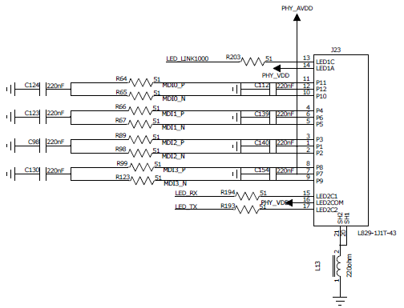

RJ45 connector schematic diagram

1. **Universal Serial Bus** 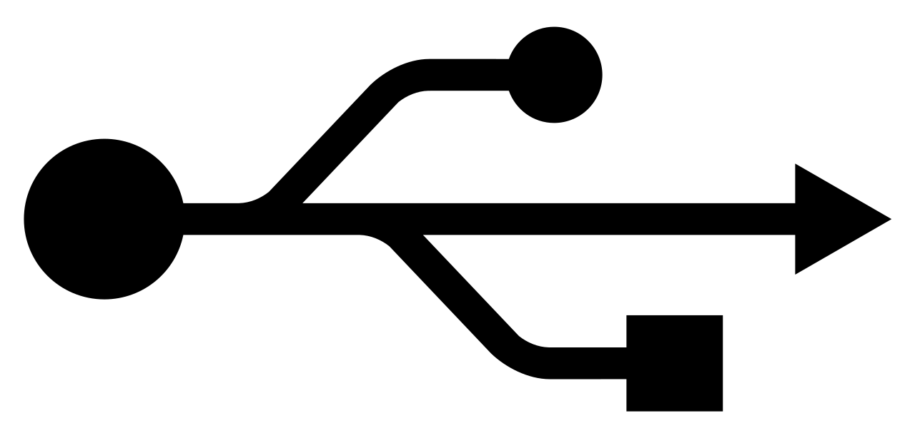

* Universal Serial Bus (USB) is an [industry standard](https://en.wikipedia.org/wiki/Technical_standard) that establishes specifications for cables and connectors and [protocols](https://en.wikipedia.org/wiki/Communication_protocol) for connection, communication and power supply ([interfacing](https://en.wikipedia.org/wiki/Interface_(computing))) between computers, [peripherals](https://en.wikipedia.org/wiki/Peripheral) and other computers. A broad variety of [USB hardware](https://en.wikipedia.org/wiki/USB_hardware) exists, including several different [connectors](https://en.wikipedia.org/wiki/USB_hardware#Connector_types), of which [USB-C](https://en.wikipedia.org/wiki/USB-C) is the most recent. Released in 1996, the USB standard is currently maintained by the [USB Implementers Forum](https://en.wikipedia.org/wiki/USB_Implementers_Forum) (USB-IF). There have been four generations of USB specifications: [USB 1.x](https://en.wikipedia.org/wiki/USB#USB_1.x), [USB 2.0](https://en.wikipedia.org/wiki/USB#USB_2.0), [USB 3.x](https://en.wikipedia.org/wiki/USB#USB_3.x) and [USB4](https://en.wikipedia.org/wiki/USB4)

|  |  |  |  |  |  |  |  |  |
| --- | --- | --- | --- | --- | --- | --- | --- | --- |
| **Connectors** | | [**USB 1.0**](https://en.wikipedia.org/wiki/USB_1.0)  **1996** | [**USB 1.1**](https://en.wikipedia.org/wiki/USB_1.1)  **1998** | **USB 2.0**  **Revised** | [**USB 3.0**](https://en.wikipedia.org/wiki/USB_3.0)  **2011** | [**USB 3.1**](https://en.wikipedia.org/wiki/USB_3.1)  **2014** | [**USB 3.2**](https://en.wikipedia.org/wiki/USB_3.2)  **2017** | [**USB4**](https://en.wikipedia.org/wiki/USB4)  **2019** |
| **Data rate** | | **1.5 Mbit/s** | **1.5 Mbit/s**  **-**  **12 Mbit/s** | **1.5 Mbit/s**  **-**  **12 Mbit/s**  **-**  **480 Mbit/s** | **5 Gbit/s** | **10 Gbit/s** | **20 Gbit/s** | **40 Gbit/s** |
| **Standard** | **A** | **Type A**  **USB Type-A receptacle.svg** | | | **Type A**  **USB 3.0 Type-A receptacle blue.svg** | | | **Deprecated** |
| **B** | **Type B**  **USB Type-B receptacle.svg** | | | **Type B**  **USB 3.0 Type-B receptacle blue.svg** | | **Deprecated** | |
| **C** | **N/A** | | | | **Type C (*enlarged*)**  **USB Type-C Receptacle Pinout.svg** | | |
| **Mini** | **A** | **N/A** | **Mini A**  **USB Mini-A receptacle.svg** | | **Deprecated** | | | |
| **B** | **Mini B**  **USB Mini-B receptacle.svg** | |
| **AB** | **N/A** | | **Mini AB**  **USB Mini-AB receptacle.svg** |
| **Micro** | **A** | **N/A** | | | | | | |
| **B** | **N/A** | | **Micro B** | **Micro B**  **USB 3.0 Micro-B receptacle.svg** | | **Deprecated** | |
| **AB** | **Micro AB**  **USB Micro-AB receptacle.svg** | **Deprecated** | | | |
| **Connectors** | | **USB 1.0**  **1996** | **USB 1.1**  **1998** | **USB 2.0**  **Revised** | **USB 3.0**  **2011** | **USB 3.1**  **2014** | **USB 3.2**  **2017** | **USB4**  **2019** |

1. **The Ethernet**

* **Ethernet** is a family of [computer networking](https://en.wikipedia.org/wiki/Computer_network) technologies commonly used in [local area networks](https://en.wikipedia.org/wiki/Local_area_network) (LAN), [metropolitan area networks](https://en.wikipedia.org/wiki/Metropolitan_area_network) (MAN) and [wide area networks](https://en.wikipedia.org/wiki/Wide_area_network) (WAN). It was commercially introduced in 1980 and first standardized in 1983 as [IEEE 802.3](https://en.wikipedia.org/wiki/IEEE_802.3). Ethernet has since been refined to support higher [bit rates](https://en.wikipedia.org/wiki/Bit_rate), a greater number of nodes, and longer link distances, but retains much [**backward compatibility**](https://en.wikipedia.org/wiki/Backward_compatibility). Over time, Ethernet has largely replaced competing wired LAN technologies such as [Token Ring](https://en.wikipedia.org/wiki/Token_Ring), [FDDI](https://en.wikipedia.org/wiki/Fiber_Distributed_Data_Interface) and [ARCNET](https://en.wikipedia.org/wiki/ARCNET).
* The original [10BASE5](https://en.wikipedia.org/wiki/10BASE5) Ethernet uses [**coaxial cable**](https://en.wikipedia.org/wiki/Coaxial_cable) as a [shared medium](https://en.wikipedia.org/wiki/Shared_medium), while the newer Ethernet variants use [**twisted pair**](https://en.wikipedia.org/wiki/Ethernet_over_twisted_pair) and [**fiber optic**](https://en.wikipedia.org/wiki/Optical_fiber) **links** in conjunction with [switches](https://en.wikipedia.org/wiki/Network_switch). Over the course of its history, Ethernet data transfer rates have been increased from the original **2.94** [**megabits per second**](https://en.wikipedia.org/wiki/Data_rate_units#Megabit_per_second)(Mbit/s) to the latest [**400 gigabits per second**](https://en.wikipedia.org/wiki/Terabit_Ethernet)(Gbit/s). The [Ethernet standards](https://en.wikipedia.org/wiki/Category:Ethernet_standards) comprise several wiring and signaling variants of the [OSI physical layer](https://en.wikipedia.org/wiki/Physical_layer) in use with Ethernet. Ethernet is widely used in homes and industry, and interworks well with Wi-Fi. The [Internet Protocol](https://en.wikipedia.org/wiki/Internet_Protocol) is commonly carried over Ethernet and so it is considered one of the key technologies that make up the [Internet](https://en.wikipedia.org/wiki/Internet).

* **Use of Wired media in different network architectures :**
* The different mediums discussed above are used in used in various Network Architectures, often many are used in combination. Here are some interesting points about Wired Network types :

1. **Wired Personal Area Network**

* Wired personal area networks provide short connections between peripherals. It mainly uses the **USB** cables to set up a small Personal network between the wired devices, but [**IEEE-1394**](https://en.wikipedia.org/wiki/IEEE-1394) or [**Thunderbolt** (interface)](https://en.wikipedia.org/wiki/Thunderbolt_(interface)) can also be used.

1. **Wired LAN**

* Wired LAN is used within a limited area such as a residence, school, laboratory, university campus or office building. Typically [Ethernet](https://en.wikipedia.org/wiki/Ethernet) is the most common wired technology in use for wired local area networks. Historical network technologies include [ARCNET](https://en.wikipedia.org/wiki/ARCNET), [Token ring](https://en.wikipedia.org/wiki/Token_ring).
* Early Ethernet ([10BASE-5](https://en.wikipedia.org/wiki/10BASE-5) and [10BASE-2](https://en.wikipedia.org/wiki/10BASE-2)) used [coaxial cable](https://en.wikipedia.org/wiki/Coaxial_cable). [Shielded twisted pair](https://en.wikipedia.org/wiki/Shielded_twisted_pair) was used in IBM's [Token Ring](https://en.wikipedia.org/wiki/Token_Ring) LAN implementation. In 1984, [StarLAN](https://en.wikipedia.org/wiki/StarLAN) showed the potential of simple [unshielded twisted pair](https://en.wikipedia.org/wiki/Unshielded_twisted_pair) by using [category 3 cable](https://en.wikipedia.org/wiki/Category_3_cable)—the same cable used for telephone systems. This led to the development of [10BASE-T](https://en.wikipedia.org/wiki/10BASE-T) (and [its twisted-pair successors](https://en.wikipedia.org/wiki/Ethernet_over_twisted_pair)) and [structured cabling](https://en.wikipedia.org/wiki/Structured_cabling) which is still the basis of most commercial LANs today.
* At the [data link layer](https://en.wikipedia.org/wiki/Data_link_layer) and [physical layer](https://en.wikipedia.org/wiki/Physical_layer), a wide variety of LAN topologies have been used, including [ring](https://en.wikipedia.org/wiki/Ring_network), [bus](https://en.wikipedia.org/wiki/Bus_network), [mesh](https://en.wikipedia.org/wiki/Mesh_network) and [star](https://en.wikipedia.org/wiki/Star_network). Simple LANs generally consist of cabling and one or more [switches](https://en.wikipedia.org/wiki/Network_switch). While [optical fiber cable](https://en.wikipedia.org/wiki/Optical_fiber_cable) is common for links between [network switches](https://en.wikipedia.org/wiki/Network_switch), use of [fiber to the desktop](https://en.wikipedia.org/wiki/Fiber_to_the_desktop) is rare.

1. **Campus Area Network (CAN)**

* CAN [computer network](https://en.wikipedia.org/wiki/Computer_network) is made up of an interconnection of [local area networks](https://en.wikipedia.org/wiki/Local_area_network) (LANs) within a limited geographical area, generally implemented using wired transmission media, [**optical fiber**](https://en.wikipedia.org/wiki/Optical_fiber)**, copper plant,** [**Cat5 cabling**](https://en.wikipedia.org/wiki/Category_5_cable) etc.The range of CAN is **1 km to 5 km.**
* College or university campus area networks often interconnect a variety of buildings, including administrative buildings, academic buildings, university libraries, campus or student centers, [residence halls](https://en.wikipedia.org/wiki/Residence_halls), [gymnasiums](https://en.wikipedia.org/wiki/Gym), and other outlying structures, like [conference centers](https://en.wikipedia.org/wiki/Convention_center), technology centers, and training institutes. Examples : the [**Stanford University Network**](https://en.wikipedia.org/wiki/Stanford_University_Network) at [Stanford University](https://en.wikipedia.org/wiki/Stanford_University), [**Project Athena**](https://en.wikipedia.org/wiki/Project_Athena) at [MIT](https://en.wikipedia.org/wiki/MIT), and the [**Andrew Project**](https://en.wikipedia.org/wiki/Andrew_Project) at [Carnegie Mellon University](https://en.wikipedia.org/wiki/Carnegie_Mellon_University)
* Corporate CANs connect several buildings like [**Googleplex**](https://en.wikipedia.org/wiki/Googleplex) and [**Microsoft**](https://en.wikipedia.org/wiki/Microsoft)**'s campus**. Campus networks are normally interconnected with high speed [Ethernet](https://en.wikipedia.org/wiki/Ethernet) links operating over [optical fiber](https://en.wikipedia.org/wiki/Optical_fiber) such as [gigabit Ethernet](https://en.wikipedia.org/wiki/Gigabit_Ethernet) and [**10 Gigabit Ethernet**](https://en.wikipedia.org/wiki/10_Gigabit_Ethernet).

1. **Metropolitan Area Network(MAN)**

* MAN is applied to the interconnection of [local area networks](https://en.wikipedia.org/wiki/Local_area_networks) (LANs) in a [city](https://en.wikipedia.org/wiki/City) into a single larger network. The term is also used to describe the interconnection of several local area networks in a metropolitan area through the use of [point-to-point connections](https://en.wikipedia.org/wiki/Point-to-point_(telecommunications)) between them.
* The telephone networks could not carry the spike that the LANs produced, so single-mode optical fiber lines were used to create MANs for companies with buildings across the city in MAN's early days. [Metro Ethernet](https://en.wikipedia.org/wiki/Metro_Ethernet), where a fibre optic ring within a larger city was built as MAN backbone carrying [Gigabit Ethernet](https://en.wikipedia.org/wiki/Gigabit_Ethernet), became common. The ring topology was implemented using the [Internet protocol](https://en.wikipedia.org/wiki/Internet_protocol) (IP), so that data could be rerouted if a link was congested or one of the links that was part of the ring failed
* Between 2002 and 2003 Sprint built three MAN rings to cover [San Francisco](https://en.wikipedia.org/wiki/San_Francisco), [Oakland](https://en.wikipedia.org/wiki/Oakland,_California) and [San Jose](https://en.wikipedia.org/wiki/San_Jose,_California), and in turn connected these three metro rings with a further two rings. Metro Ethernet was effectively the extension of [Ethernet](https://en.wikipedia.org/wiki/Ethernet) protocols beyond the [local area network](https://en.wikipedia.org/wiki/Local_area_network) (LAN) and the ensuing investment in Ethernet led to the deployment of [carrier Ethernet](https://en.wikipedia.org/wiki/Carrier_Ethernet), where Ethernet protocols are used in [wide area networks](https://en.wikipedia.org/wiki/Wide_area_networks) (WAN). DE-CIX has gone on to establish carrier neutral metropolitan Internet Exchanges in [New York](https://en.wikipedia.org/wiki/DE-CIX_New_York), Madrid, [Dubai](https://en.wikipedia.org/wiki/UAE-IX), [Marseille](https://en.wikipedia.org/wiki/DE-CIX_Marseille), Dallas, Hamburg, [Munich](https://en.wikipedia.org/wiki/ALP-IX), Düsseldorf, Berlin, Istanbul, [Palermo](https://en.wikipedia.org/wiki/DE-CIX_Palermo), Lisbon, [Mumbai](https://en.wikipedia.org/wiki/Mumbai_IX), Delhi, Kolkata, Chennai, and Moscow

1. **Storage Area Network (SAN)**

* A storage area network (SAN) or storage network is a [computer network](https://en.wikipedia.org/wiki/Computer_network) which provides access to consolidated, [block-level data storage](https://en.wikipedia.org/wiki/Block_device). SANs are primarily used to access storage devices, such as [disk arrays](https://en.wikipedia.org/wiki/Disk_array) and [tape libraries](https://en.wikipedia.org/wiki/Tape_library) from [servers](https://en.wikipedia.org/wiki/Server_(computing)) so that the devices appear to the [operating system](https://en.wikipedia.org/wiki/Operating_system) as [direct-attached storage](https://en.wikipedia.org/wiki/Direct-attached_storage). SANs have their own networking devices, such as SAN switches. To access the SAN, so-called SAN servers are used, which in turn connect to SAN [host adapters](https://en.wikipedia.org/wiki/Host_adapter). Within the SAN, a range of data storage devices may be interconnected, such as SAN-capable disk arrays, JBODS and [tape libraries](https://en.wikipedia.org/wiki/Tape_libraries).
* When SANs were first built, hubs were the only devices that were [Fibre Channel](https://en.wikipedia.org/wiki/Fibre_Channel) capable, but **Fibre Channel switches** were developed and hubs are now rarely found in SANs. Switches have the advantage over hubs that they allow all attached devices to communicate simultaneously, as a switch provides a dedicated link to connect all its ports with one another. When SANs were first built Fibre Channel had to be implemented over copper cables, these days **multimode** [**optical fibre cables**](https://en.wikipedia.org/wiki/Optical_fiber) are used in SANs

1. **Wide Area Network (WAN)**

* A wide area network (WAN) is a [telecommunications network](https://en.wikipedia.org/wiki/Telecommunications_network) that extends over a large geographical area for the primary purpose of [computer networking](https://en.wikipedia.org/wiki/Computer_network). Wide area networks are often established with [**leased telecommunication circuits**](https://en.wikipedia.org/wiki/Leased_line).
* Typically, leased lines are used by businesses to connect geographically distant offices. An Internet leased line is a premium Internet connectivity product, normally delivered over **fiber**, which provides uncontended, symmetrical bandwidth with **full-duplex** traffic. It is also known as an **Ethernet leased line**, [dedicated line](https://en.wikipedia.org/wiki/Dedicated_line), data circuit or [private line](https://en.wikipedia.org/wiki/Private_line).
* Many technologies are available for wide area network links. Examples include [circuit-switched](https://en.wikipedia.org/wiki/Circuit_switching) telephone lines, [radio wave](https://en.wikipedia.org/wiki/Radio_wave) transmission, and [optical fiber](https://en.wikipedia.org/wiki/Optical_fiber). New developments in technologies have successively increased transmission rates. In ca. 1960, a 110 bit/s (bits per second) line was normal on the edge of the WAN, while core links of 56 kbit/s to 64 kbit/s were considered fast. As of 2014, households are connected to the Internet with [dial-up](https://en.wikipedia.org/wiki/Dial-up_Internet_access), [asymmetric digital subscriber line](https://en.wikipedia.org/wiki/Asymmetric_digital_subscriber_line) (ADSL), [cable](https://en.wikipedia.org/wiki/Cable_Internet_access), [WiMAX](https://en.wikipedia.org/wiki/WiMAX), [4G](https://en.wikipedia.org/wiki/4G) or [fiber](https://en.wikipedia.org/wiki/Fiber-optic_communication). The speeds that people can currently use range from 28.8 kbit/s through a 28K [modem](https://en.wikipedia.org/wiki/Modem) over a telephone connection to speeds as high as **100 Gbit/s** using [**100 Gigabit Ethernet**](https://en.wikipedia.org/wiki/100_Gigabit_Ethernet).

1. **Global Network**

* Interconnected [IP networks](https://en.wikipedia.org/wiki/IP_network) (principally the [Internet](https://en.wikipedia.org/wiki/Internet), with estimated 2.5 billion users worldwide in 2014), and the [GSM](https://en.wikipedia.org/wiki/GSM) [mobile communication](https://en.wikipedia.org/wiki/Mobile_communication) network (with over 6 billion worldwide users in 2014) form the largest global networks of all.
* Many applications run on several networks, such as [VoIP](https://en.wikipedia.org/wiki/VoIP) (voice over IP). [Mobile communication](https://en.wikipedia.org/wiki/Mobile_communication) (voice and data) networks are also intimately intertwined, because the majority of 21st century [cell phones](https://en.wikipedia.org/wiki/Cell_phone) have both voice and data (internet navigation and [emailing](https://en.wikipedia.org/wiki/Email)) capabilities. Digital global networks require huge carrying capacity in the main [backbones](https://en.wikipedia.org/wiki/Internet_backbone). This is currently achieved by [**fiber optic** cables](https://en.wikipedia.org/wiki/Fiber_optic_cable).
* **References :**
* <https://en.wikipedia.org/wiki/WiMAX>
* <https://en.wikipedia.org/wiki/Fiber-optic_communication#Applications>
* <https://en.wikipedia.org/wiki/Wide_area_network#Connection_technology>
* <https://en.wikipedia.org/wiki/Smart_city#Technologies>
* <https://en.wikipedia.org/wiki/Campus_network>
* <https://en.wikipedia.org/wiki/Global_network>
* <https://en.wikipedia.org/wiki/Storage_area_network>
* <https://en.wikipedia.org/wiki/Metropolitan_area_network>
* <https://en.wikipedia.org/wiki/Local_area_network>
* <https://en.wikipedia.org/wiki/Personal_area_network>
* <https://en.wikipedia.org/wiki/USB>
* <https://en.wikipedia.org/wiki/Ethernet_over_twisted_pair>
* <https://en.wikipedia.org/wiki/Optical_fiber#Communication>
* <https://en.wikipedia.org/wiki/Cable_Internet_access>
* <https://en.wikipedia.org/wiki/Fiber-optic_cable><https://en.wikipedia.org/wiki/Ethernet>
* <https://en.wikipedia.org/wiki/Twisted_pair>
* <https://en.wikipedia.org/wiki/Coaxial_cable>
* <https://en.wikipedia.org/wiki/Space_Network>
* <https://en.wikipedia.org/wiki/Wireless_mesh_network>
* <https://en.wikipedia.org/wiki/Fixed_wireless#Fixed_wireless_broadband>
* <https://www.connectify.me/>
* <https://www.cnet.com/news/intels-my-wifi-makes-my-internet-yours/>
* <https://en.wikipedia.org/wiki/Near-field_communication>
* <https://en.wikipedia.org/wiki/Wi-Fi>
* <https://en.wikipedia.org/wiki/Zigbee>
* <https://en.wikipedia.org/wiki/Free-space_optical_communication>
* <https://en.wikipedia.org/wiki/Infrared>
* [https://en.wikipedia.org/wiki/Bluetooth](https://en.wikipedia.org/wiki/Bluetooth#Communication_and_connection)
* <https://en.wikipedia.org/wiki/Wireless_network>
* <https://en.wikipedia.org/wiki/Wired_communication>
* **Conclusion :**
* We havediscussed different types of physical layer wired/wireless connections, in great detail, highlighting some interesting facts and focusing on the applicability of the various technologies in the various network architectures.